Elect Tamara Lorincz - New Democrat Candidate for Halifax West
  Tamara Lorincz  A woman of integrity and action  for people and the planet. | Meet Tamara Lorincz - Tamara has been a hard-working passionate leader in our community for many years. She is a graduate of Dalhousie University with a Bachelor of Law and a Master of Business Administration (MBA, LLB). Tamara is the Executive Director of the Nova Scotia Environmental Network and the Coordinator of SENSE: Sustainability Education in NS for Everyone. She has an impressive record of work and service on the environment, sustainability, social justice, women and children’s, immigration, fair trade, peace, and corporate social responsibility issues. It is because of this legacy that Tamara was asked by the New Democrat Party as the candidate for Halifax West. In March 2007, Tamara accepted the nomination of Graham Steele, NDP MLA for Fairview, and Dr. Randi Warne, Coordinator of Cultural Studies at Mount St. Vincent University. Tamara is running to be a strong voice for the environment, working families, a prosperous economy, education, and healthcare - the priorities of the people of Halifax West.  The citizens of Halifax West deserve a hard-working, effective Member of Parliament. Someone who is courageous and committed to stand up for our cherished Canadian values.  It is time for a change in Halifax West. It is time for a change in Ottawa.
Why I am Running for Public Office: (Find out more about the New Democrat Plan: www.ndp.ca)
- For Urgent Real Action on Environment and Climate Change  - For Equality and Fairness for Women  - For Affordable Education and Training  - For a Green, Strong Economy  - For Public Health Care and For the Best Care of our Seniors  - For Working Families & Energy Security  - For the Millennium Development Goals |  | - For Leadership and Accountability  - For a Real Choice for Child Care  - For Our Kids – Youth Empowerment  - For Peace and Peacekeeping  - For the Arts & Our Cultural Heritage  - To Close the Income Gap  - To Eliminate Poverty
"Tamara Lorincz inspires collaborative action and leads by example. In short, she is exactly what Parliament - and this country - needs!"
- Dr. Randi R. Warne, Coordinator, Cultural Studies, Mount St. Vincent University

The House of Commons in Canada needs Tamara and her dedication to our environment."
— Peter Stoffer, NDP Member of Parliament, Sackville-Eastern Shore

"Tamara Lorincz has shown a real commitment to social justice issues through her efforts to promote, educate and involve people in equality and human rights issues. I give my unequivocal support to Tamara."
- Rick Clarke, President, Nova Scotia Federation of Labour

"Tamara Lorincz is exactly the kind of person we need to represent us in Parliament. She's committed, energetic and fearless."
— Graham Steele, MLA Halifax Fairview

Unite for Change - Help Elect Tamara Lorincz as our New Democrat Member of Parliament on Tuesday, October 14.

Take a Sign. Spread the Word. Join our Campaign. Donate. Vote. Campaign Office is 256 Bedford Highway.

Phone: 455-4NDP (4637) /Email: tamaralorincz@ndp.ca / Web Site: www.tamaralorincz.ca
Printed on 100% post-consumer recycled paper | 
OVER →
Elect Tamara Lorincz - Federal NDP MP for Halifax West
"I am thrilled Tamara Lorincz has joined the NDP team. Her tireless work in the community raising awareness and propelling action on a wide range of issues are impressive. She's smart, accomplished and hard working. She will make a fabulous Member of Parliament representing the people of Halifax West."
- Alexa McDonough, NDP Member of Parliament, Halifax

  Tamara Lorincz  with husband Ben and their children Sam and Will  A woman of integrity and action for  people and the planet.  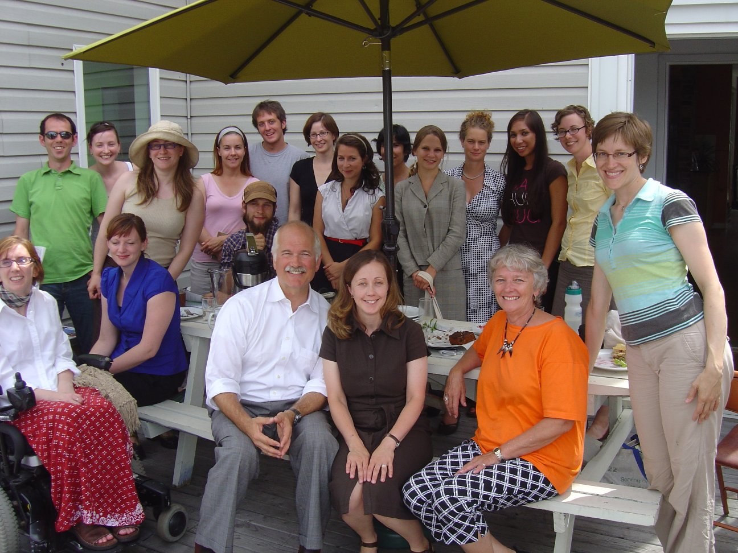  Tamara with NDP Leader Jack Layton and MP Alexa McDonough and local environmentalists  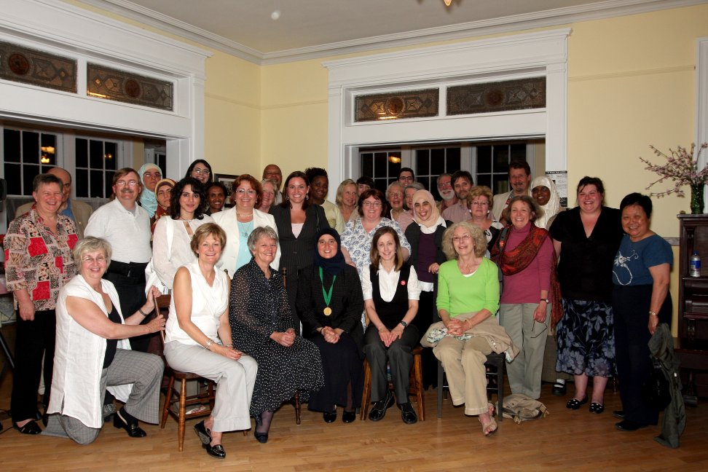  Tamara with Dr. Monia Mazigh, human rights advocate, and many supporters at the event A Woman’s Struggle for Justice | Well-known, Respected Environmentalist.  - Executive Director of the Nova Scotia Environmental Network  - Coordinator of the SENSE: Sustainability Education in Nova Scotia For Everyone  - Member, Minister’s Roundtable on the Environment and Sustainable Prosperity  - Director, National board of EcoJustice Canada (formerly the Sierra Legal Defence Fund)  - Founding Director, East Coast Environmental Law Association  - Founding Advisory Committee Member, Atlantic Canada Sustainability Initiative  - Short-listed twice for the Ecology Action Centre’s Annual Sunshine Award (2006, 2008)  Smart. Stong Business Experience.  - Bachelor of Criminology (University of Alberta)  - Bachelor of Commerce (University of Victoria)  - Masters of Business and Law (MBA/LLB), Dalhousie University  - Collaborator on the Canadian Business Ethics Research Network  - Member of the Research Network for Business Sustainability  - Founded the Society for Corporate Environmental and Social Responsibility  - Received the Inaugural Corporate Knights National Student Leadership Award  - Worked at the Centre For Entrepreneurship Education & Development (CEED) helping young entrepreneurs realize their dreams of opening their own business  - Interned as a Commercial Officer for the Canadian Embassy in Norway  - Tamara believes that by closing the gender gap and greening the economy, Canada will prosper and become more sustainable  Passionate Advocate for Women, Children and Social Justice.  - Appointed by the NS Advisory Council on the Status of Women to be the Nova Scotia Representative on the Atlantic Advisory Committee for Maternity and Parental Benefits  - Founding Member of Equal Voice Nova Scotia dedicated to promoting the election of more women in Canada  - Member of the National Association of Women and the Law  - Member of Oxfam, the Voice of Women for Peace, Pugwash Peace Exchange, the Halifax Peace Coalition and the international board of the Global Network Against Nuclear Power and Weapons in Space with Nobel peace prize nominee Dr. Helen Caldicott  - Received the Peace in Space Award in New York with co-recipient Steve Staples, Director of the Rideau Institute.  Proven Community Leader.  - Professional mentor at Metropolitan Immigrant Settlement Association volunteer program  - Member of Build-It-Right and Prepared the Green Building Background Document  - Supporter of the Birch Cove Lakes-Blue Mountain Candidate Wilderness Area  - Founder of the Dump & Run: The Largest Community Garage Sale that raise tens of thousands of dollars every year for local non-profits and charities  - Has organized hundreds of events: workshops, film screenings, seminars and campaigns to help get information on the environment, green business and social justice to the people

UPCOMING EVENT: Meet Tamara and Help Clean Up Half-Mile Lake Sat., Sept. 20 from 10:00-12:00 p.m. Join Tamara and neighbours for the clean up of Half-Mile Lake in Timberlea. The clean up will be followed by a pizza Open House from 12-1:00 pm. Meet for the clean up at the corner or Red Maple Dr. and Silver Maple Dr. (Rain date is Sept. 21)In conjunction with the TD National Great Shore Clean Up! More details: www.tamaralorincz.ca
Authorized by the Official Agent of Tamara Lorincz

